Name: | Date:
Graded Assignment
Unit Test Part 2: Nutrition

1)Briefly describe three of the key recommendations of the Dietary Guidelines for Americans.

2)Answer the following questions using the information from the nutrition facts label below.

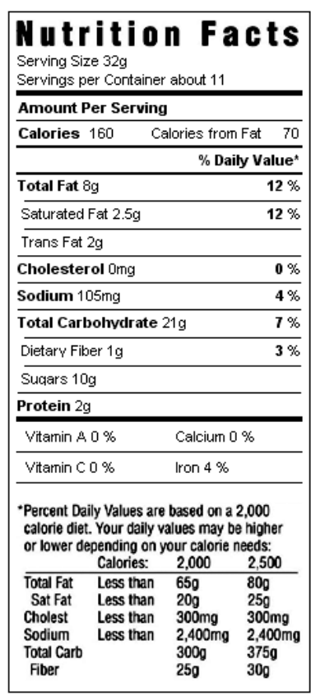
- If you eat the entire bag, how many calories have you consumed?
- If you eat the entire bag, what percent of daily value of fat have you consumed?
- If you eat one serving, what percent of the daily value of saturated fat have you consumed?
- If you eat one serving, how many grams of dietary fiber have you consumed?
- Are there enough servings in this container to reach 100% of the recommended daily value for vitamin C?

3)Describe the following influences on our food choices and provide an example of each one.
- Your cultural background

- Product packaging

- Product pricing

4)Pick three risky weight-loss strategies from this list: fad diets, liquid diets, laxatives and diuretics, and fasting/starvation diets. Write a paragraph for each strategy that defines it and explains its risk.

